
Human Biology – General Year 12 Task 2 – Unit 3
Name: _________________________________
Assessment type: Science Inquiry (Practical)
Conditions: -------------/22 = ------------------------
Period allowed for completion of the task:
- Tuesday the 5th of March
Task weighting: 8% of the school mark for Units 3 and 4
Task 2: Science Inquiry (Practical): Chicken Wing Dissection (22 marks)
To be read before the practical:
Safety precautions:
- Since you will be handling raw chicken, which may have germs on the surface, please wash your hands with soap and water before and after this procedure.
- You may use rubber gloves if desired, or bare hands if you prefer.
- To reduce the chance of jabbing or cutting yourself, the only tools you will need are scissors and tweezers.
- Wash all equipment in hot soapy water when done.
- Discard the chicken wing and parts at the end of this exercise.
The practical:
Step One: Examine the intact wing
- Holding the wing at the shoulder and wing tip, fully extend the wing.
- Note the locations of the joints where the wing bends.
- Note the directions in which the joints bend.
- Use your fingers to feel the bones and muscle bundles beneath the skin.
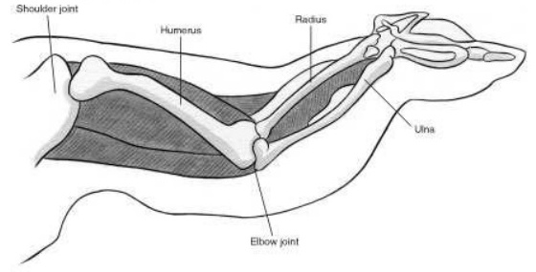
- Note the locations where the feathers were inserted into the skin.

Image 1: A chicken wing. Image taken from http://www2.nau.edu/lrm22/lessons/chicken_wing/wing.html
Step Two: Remove the skin
- Using the scissors, remove as much of the skin as you can, cutting along the line of the bones.
- Be careful not to cut the muscles, ligaments, and tendons.
- Blot dry any fat with a paper towel, and remove it to expose the underlying anatomy.
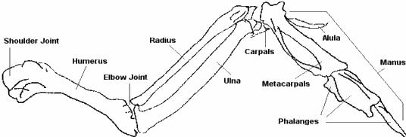
Image 2: Bones found in a chicken wing. Image taken from http://www2.nau.edu/lrm22/lessons/chicken_wing/wing.html

Step Three: Examine the soft tissues
- Locate the two muscle bundles that bend and straighten the lower section of the wing, below the elbow joint, by pulling on each muscle in turn.
- Note that these muscles are in opposition to each other. When one tightens, the other lengthens.
- Note the points at which these muscles attach to the bone, and carefully remove them one by one.
- Locate the cartilage at the joint between the humerus and radius/ulna.
Questions:
- Use a ruler to fill in the measurements for the below image (7 marks)

- Where are the muscles that move the lower wing located? (1 mark)
______________________________________________________________________________________________________________________________________________________

The following three questions relate to your arm and hand.
- Bend your arm at the elbow and hold it tight. Notice that your bicep muscle shortens. Now, extend your arm. What happens to your bicep? (2 marks)
_________________________________________________________________________________________________________________________________________________________________________________________________________________________________

- Look at your hand. Describe where the muscles are that move your fingers. (Hint: Press on your wrist and forearm while wiggling your fingers.) (3 marks)
____________________________________________________________________________________________________________________________________________________________________________________________________________________________________________________________________________________________________________

- Why is the thumb so important for gripping objects? Try to pick something up without using your thumb. Explain some of the difficulties that could be faced by someone with no thumb.
(4 marks)
____________________________________________________________________________________________________________________________________________________________________________________________________________________________________________________________________________________________________________
____________________________________________________________________________________________________________________________________________________________________________________________________________________________________________________________________________________________________________

Participation mark for practical (5 marks) Note: To obtain full marks for participation, you will need to actively participate in the practical in a group setting.

